CSMON Fast to Go Manual

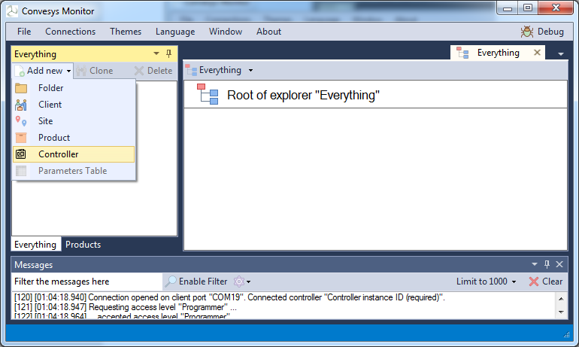

Select Add New Controller

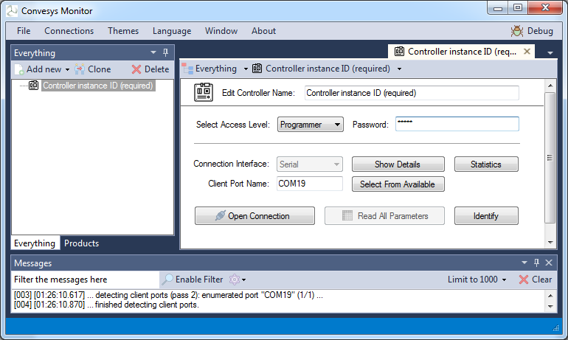

Select Access Level Programmer Password: 01234

Select Serial Port and Click on Show Details

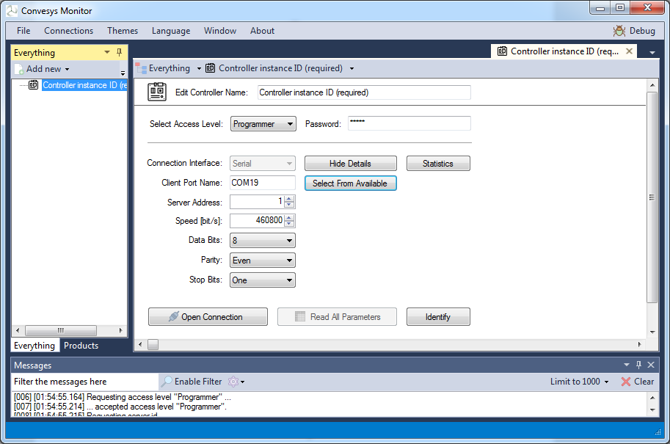

Select Parity Even (Default) and 460800 Baud

Click Open Connection. Click All Parameters.

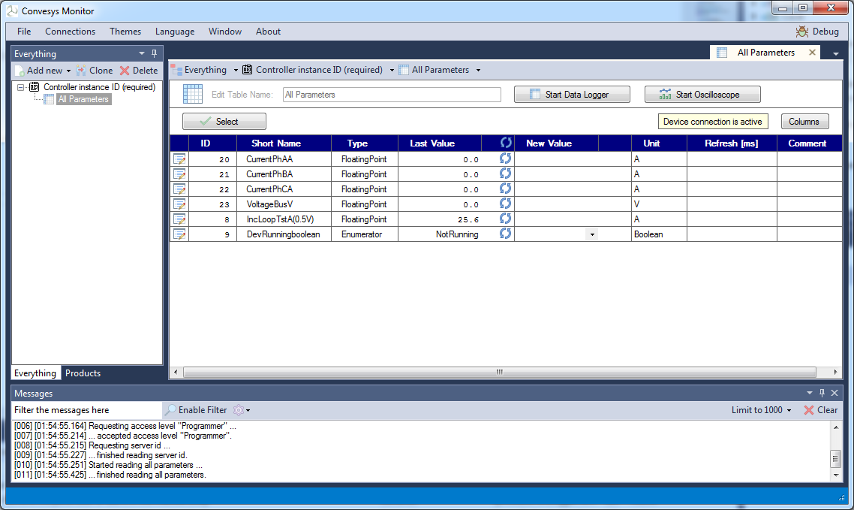

Fast to Go Recorder

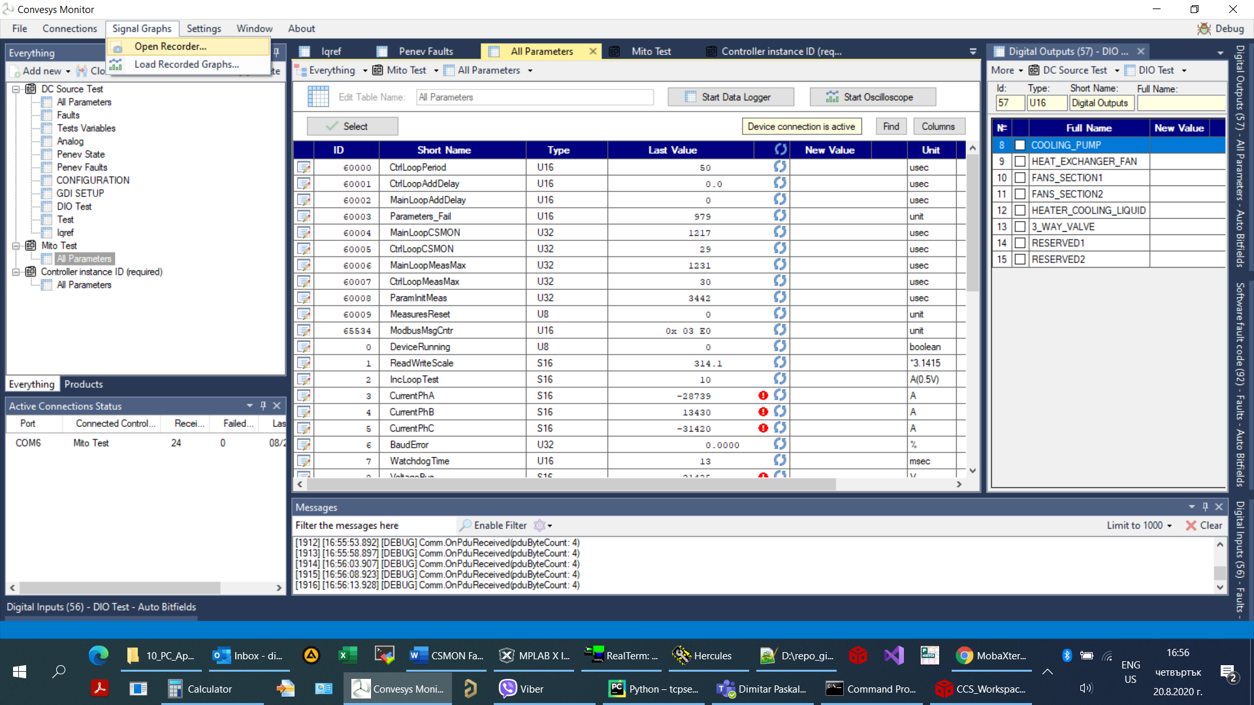

Select “Signal Graphs” -> ”Open Recorder…”

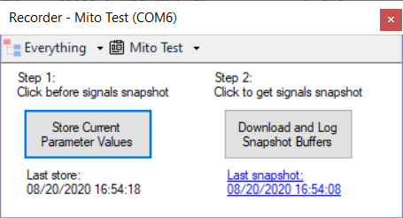

Recorder Button Dialog Shows

Click Download and Log Snapshot Buffers

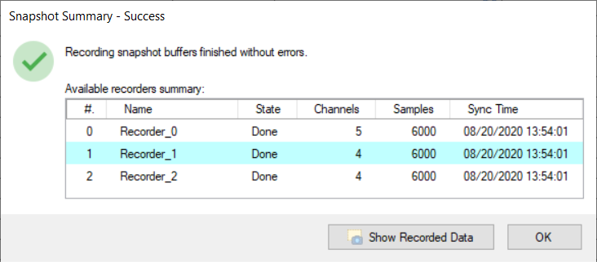

Summary must Pop-up

Click Show Recorded Data

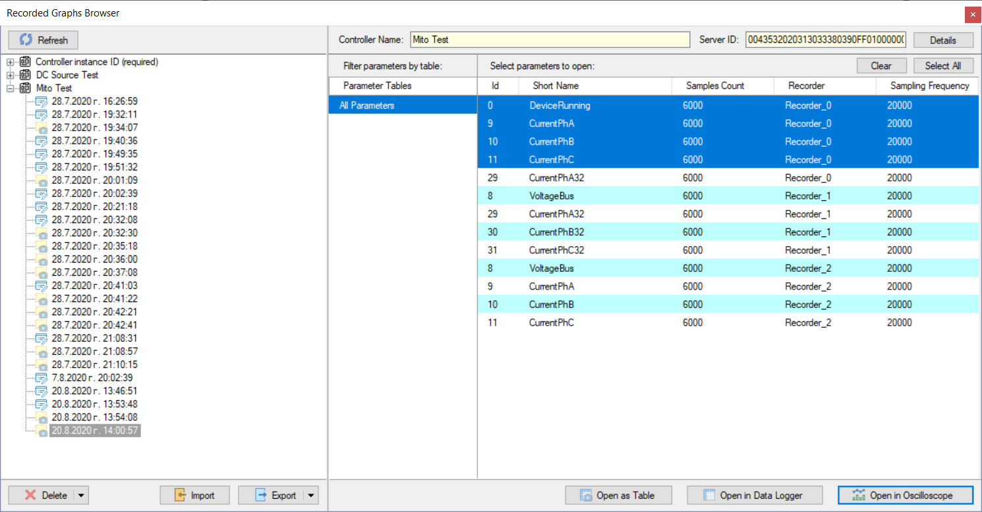

Recorder Graphs Browser is Shown

Select Some Parameters and press

Open in Oscilloscope

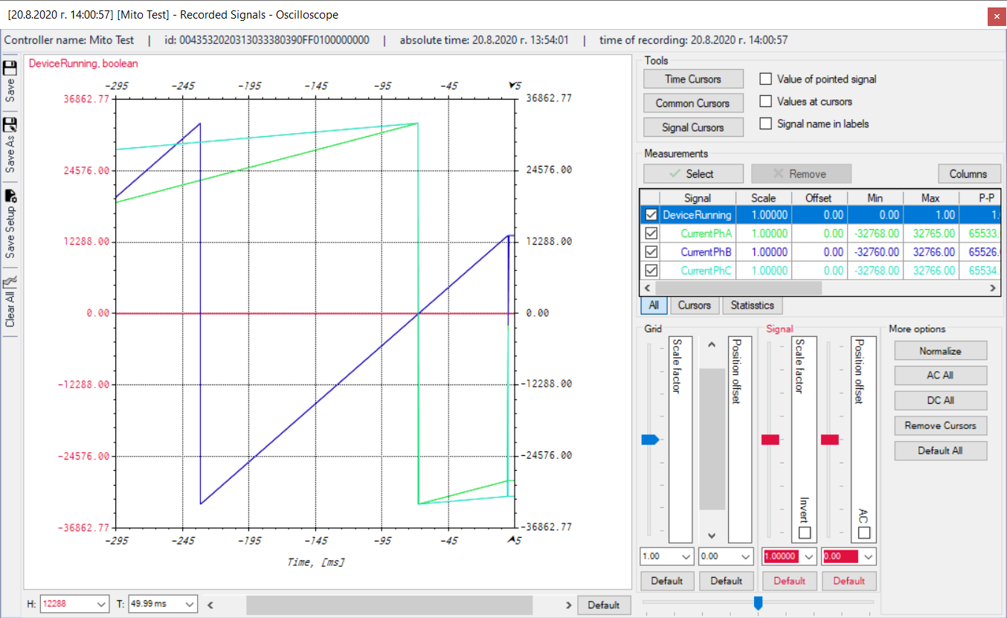

Oscilloscope Should be Shown